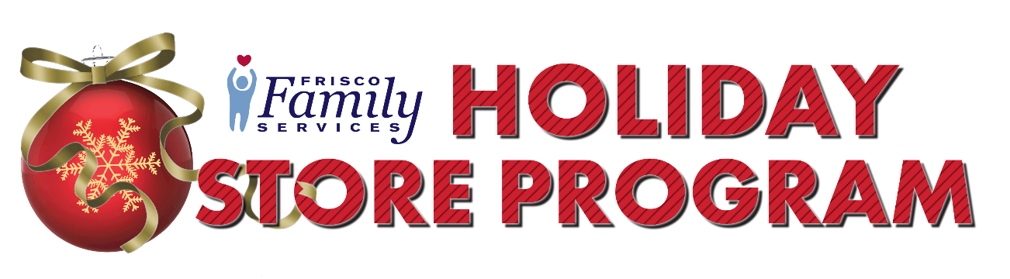

**Please help Frisco Family Services provide more than**

**1000 individuals with gifts through our annual Holiday Store Program!**

**What:** Frisco Family Services Holiday Store Program relieves much of the stress for our neighbors in crisis during the holiday season. Because of the generous donations you and your community previously provided, around 1000 individuals were able to shop for age appropriate gifts for their families and themselves at our no-cost “holiday store”. We hope you continue to make the holidays brighter for those who need our support!

**Who:** Any group, company, organization or individual willing to donate a gift can become a sponsor.

**How You Can Help:**

* **Provide a family with pajamas.** You will be provided with the sizes for each member of a household in order to ensure that the whole family has some new pajamas to stay warm in over the Holidays.
* **Fill an ornament.** Each one of our gift “ornaments” represents a single new, unused gift for a child, 0 – 5th grade. We will provide you with the requested number of gift ornaments. You will receive a spreadsheet from FFS to track your records. **Please tape each ornament to your unwrapped gift.**
* **Provide a $25 gift card.**  Due to COVID, we will primarily be asking for gift cards for teenagers and adults. Your $25 gift card can be to H&M, Kohl’s, Old Navy, Visa, or Mastercard.
* **Provide a $10 gift card** to a fast food restaurant such as Whataburger, Chick Fil A, or McDonalds.
* **Fill a stocking** with goodies such as candy, toothbrushes, toothpaste, chap sticks, coloring books, stickers, games, etc., for a child or teen. We ask that all stockings are non-gendered.Stockings donated by the Frisco Quilt Guild will be provided.
* **Host a holiday drive** for specific items such as gift cards, toys, blankets, pajamas, and more.
* **Donate:** Make a cash or gift card contribution to the program.

**When: Return the attached sponsorship form by mail or email.** If, for any reason, you are unable to fulfill your commitment, please notify us no later than Nov. 18 so those ornaments can be redistributed. **Return all UNWRAPPED gifts the week of Dec. 7- 9th to our Holiday Store address.** If you need to make special drop off arrangements, please call us. Distribution will be Dec 15th-17th.

**Where:** 6850 Gaylord Pkwy, Frisco, TX 75034

**Questions:** Please feel free to email us at [programs@friscocenter.org](mailto:programs@friscocenter.org) or call us at 972-335-9495 with any questions you may have.

**Thank you for your participation and continued support in making**

**this a special holiday season for so many in our community!**

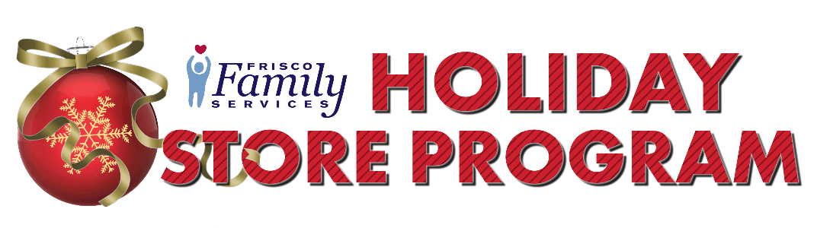**Holiday Store Program Sponsorship Form**

Group/Organization/Individual Name:___________________________________________________

Contact Person:____________________________________________________________________

Mailing Address: ___________________________________________________________________

City, State, Zip Code:________________________________________________________________

Phone #:___________________ Email Address:__________________________________________

**We will help by:**

______ Providing ___(qty.) **families with pajamas**. Sizes will be provided to you.

______ Providing ____(qty.) **CHILDRENS’ gift ornaments** (children ages 0-12 only)

______ Providing _____(qty.) **TEEN $25 gift cards** (to H&M, Old Navy, or Kohl’s)

______ Providing _____(qty.) **TEEN $10 fast food gift cards** (Whataburger, Chick Fil A, or McDonalds)

______ Providing _____(qty.) **PARENT/ADULT $25 gift cards** (to Visa or Mastercard)

______ Making a **cash donation** of $________

______ Hosting a **holiday drive** and collect__________________________(item or items)

______ Filling _____(qty.) **stockings** with goodies for __________________(girl child, boy child, girl teen, or boy teen). Stockings provided by FFS.

______ **Volunteering**

**Please return this form via email**Contact us after this date to find out the status of our needs.

Forms can be dropped off at 8780 3rd Street, Frisco, 75034; mailed to PO Box 1387, Frisco, TX 75034 or emailed to [programs@friscofamilyservices.org](mailto:programs@friscofamilyservices.org).